Data Visualisation Using Tableau
Car Insurance Claims
- ANIRUDHA K R

Link of the project:
https://public.tableau.com/views/CarInsuranceClaims_17914850088240/CarInsuranceClaim?:language=en-US&:sid=&:redirect=auth&:display_count=n&:origin=viz_share_link

Project Overview
- Exploratory Data Analysis
- Calculated Field Creation
- Parameter Creation
- Dashboard Creation
- Storyboard Creation
- Executive Summary
- Quality of Submission

- Exploratory Data Analysis
Exploratory Data Analysis (EDA) was performed on the Car Insurance Claims dataset to understand customer characteristics, vehicle profiles, claim behaviour and potential business risks. Different types of charts were used to identify patterns, distributions and relationships within the data.
The analysis focuses on converting the raw data into quantifiable and business-oriented insights that support the overall insurance story.
- Charts Used for EDA
The following chart types were selected from the mandatory list:
- Bar Chart – Customer Distribution by Car Type
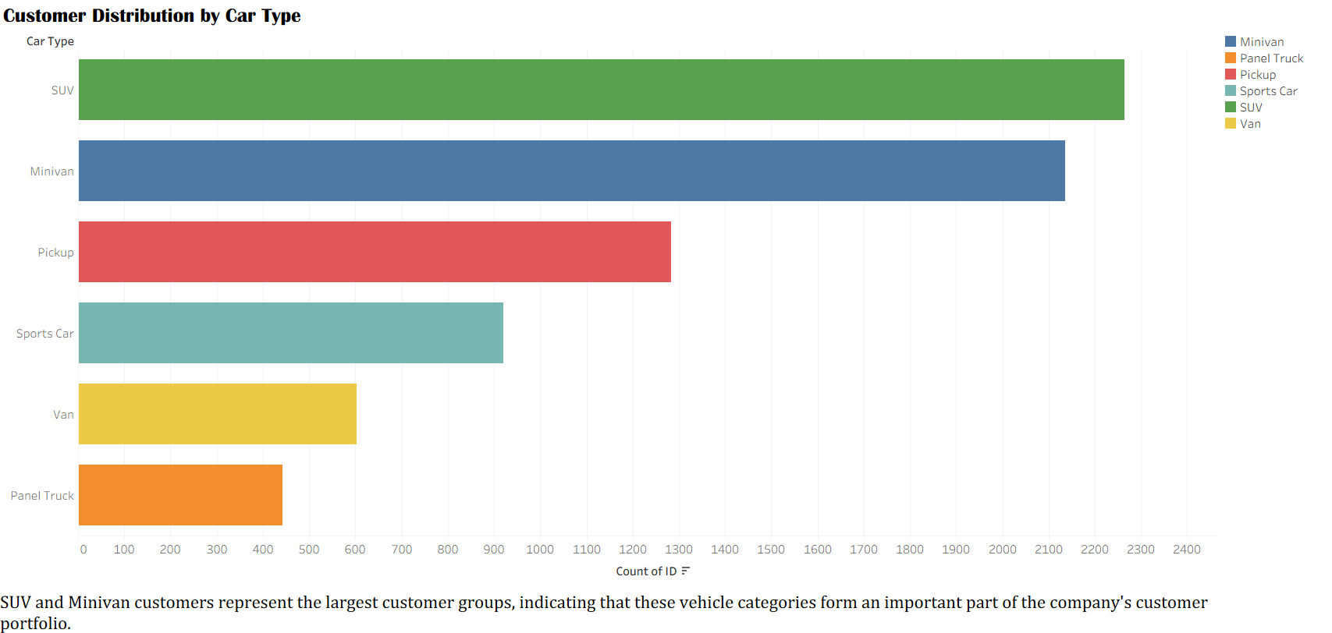
- Bar Chart – Customer Distribution by Vehicle Use
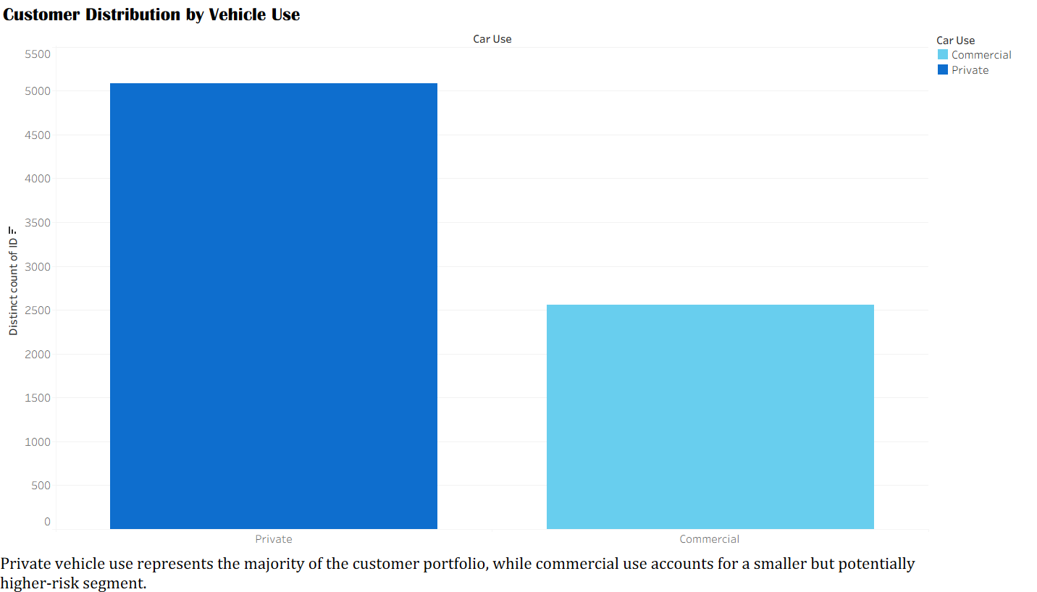

- Histogram – Customer Income Distribution
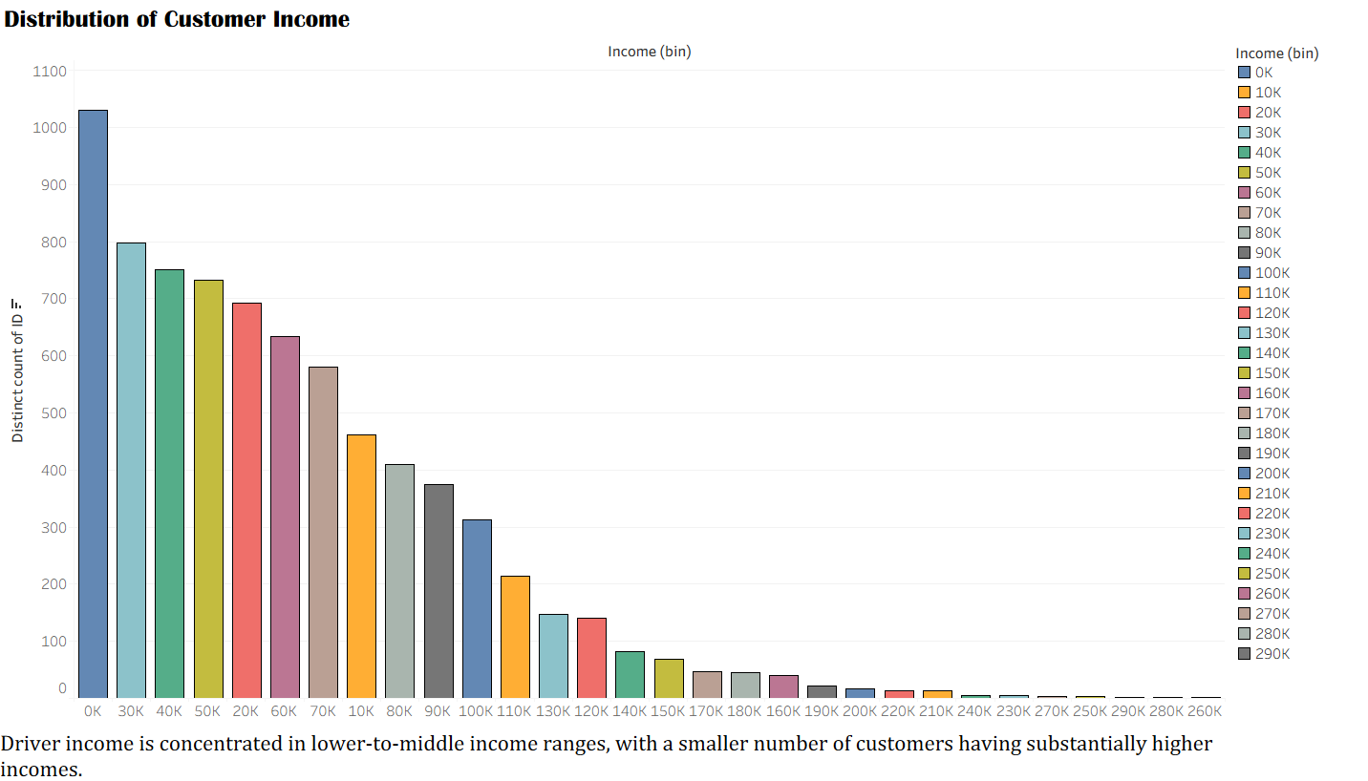
- Bar Chart – Average Income by Occupation
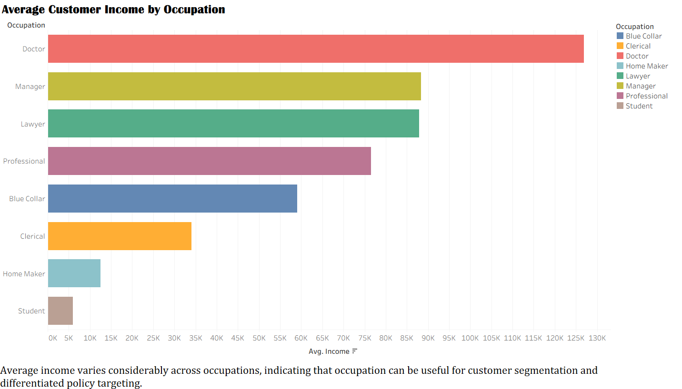
- Scatterplot – Home Value vs Income
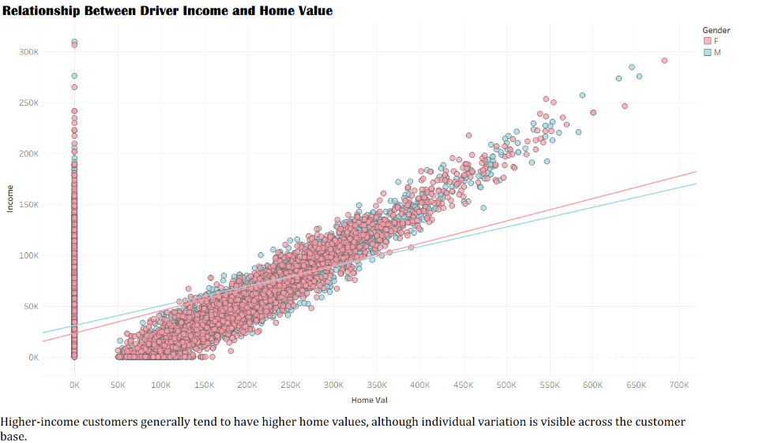

- Pareto Chart – Claim Amount Contribution by Car Type
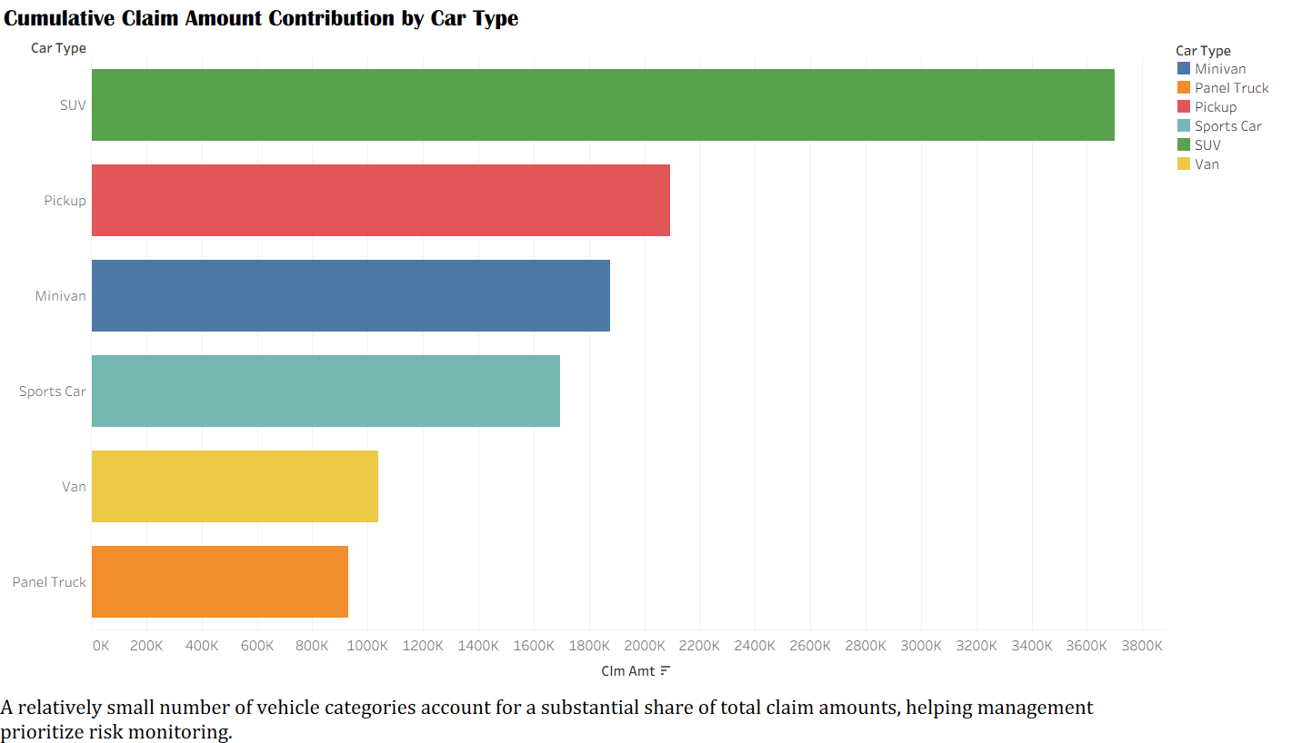
- Heatmap – Occupation vs Vehicle Use
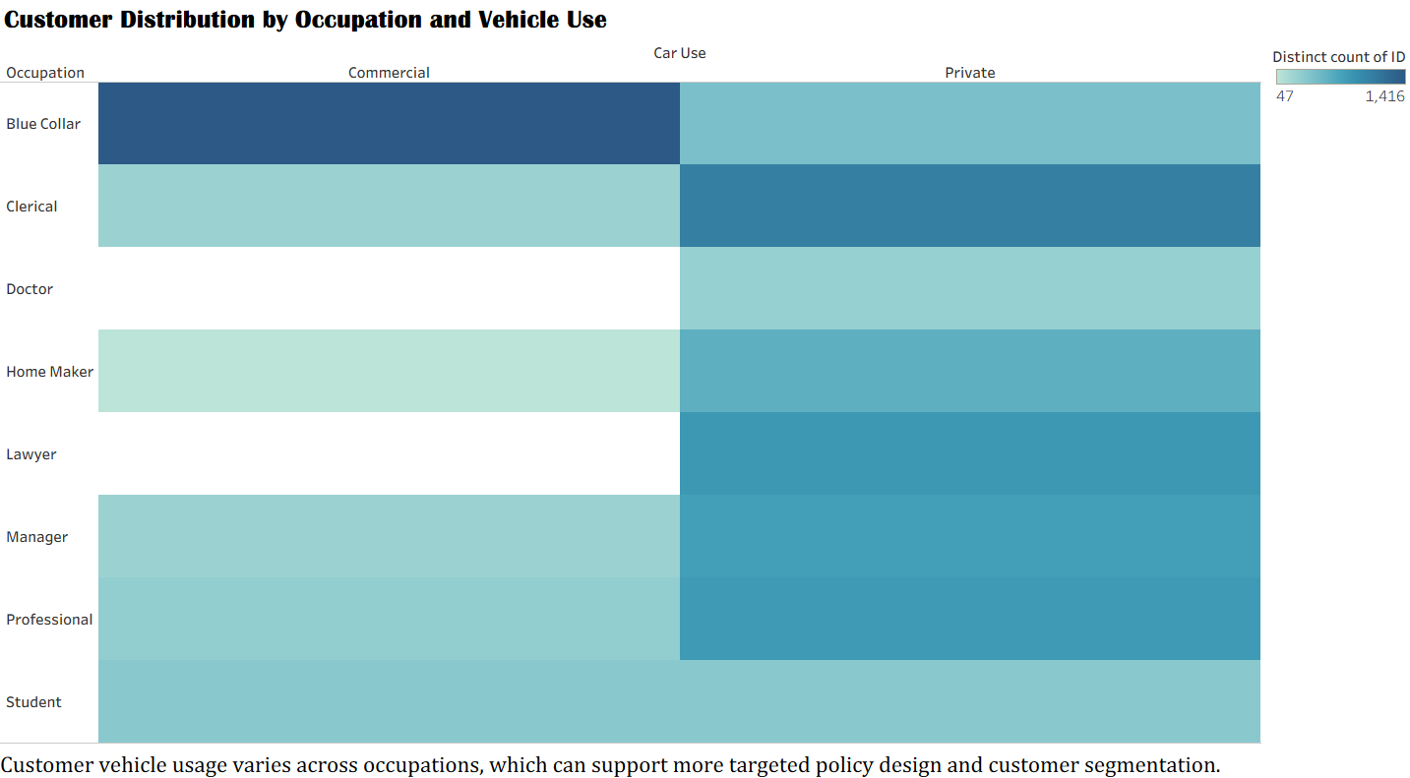
- Histogram – Travel Time Distribution
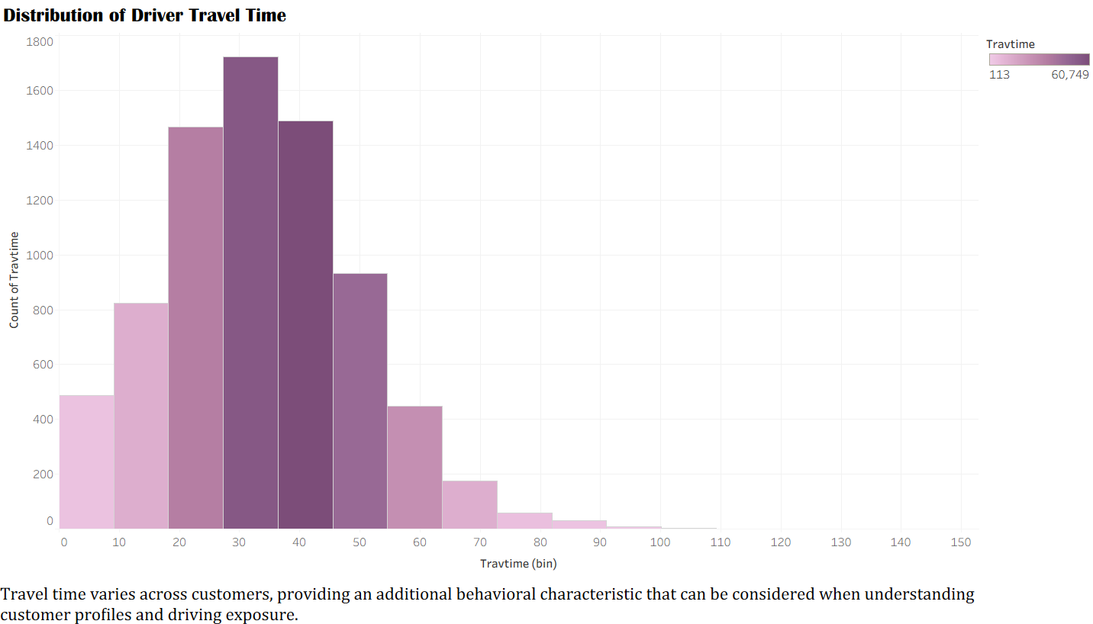

- Key Business Insights
- SUVs and Minivans represent some of the largest customer groups, indicating strong customer presence in these vehicle categories.
- Private vehicle usage is higher than Commercial usage, showing that the majority of customers use their vehicles privately.
- Average income varies considerably across occupations, with higher-income occupations representing stronger customer-value segments.
- Income and home value show a positive relationship, indicating that customers with higher income generally tend to have higher home values.
- Claim amounts are concentrated among specific car types, allowing the insurer to identify vehicle categories contributing more to overall claim costs.
- Customer distribution varies across occupations and vehicle usage, providing opportunities for more detailed customer segmentation.
- Travel time varies across customers, which can provide additional context when understanding driving exposure and potential risk.

- Business Perspective
The EDA provides an initial understanding of the customer base, vehicle characteristics, financial profile and claim behaviour. These findings form the foundation for the subsequent Key Question analysis, dashboards and Story, where specific relationships such as education vs income, vehicle age vs claim frequency and vehicle use vs claim amount are examined in greater detail.

- Overall Purpose
The EDA helps identify important patterns, high-value customer segments and potential claim-risk areas before moving into deeper business analysis. The findings are used to build a logical story from customer and vehicle profile → financial characteristics → claim behaviour → risk and business recommendations.

- Calculated Field Creation
Two calculated fields were created in Tableau to enhance the analysis and provide meaningful business insights from the car insurance claims dataset.

1. Age Group
An Age field was first calculated using the customer's BIRTH date. The calculated Age was then used to create the Age Group field, categorizing customers into meaningful age ranges such as Below 50, 50–59, 60–69, 70–79, 80–89, and 90+.
This classification makes it easier to understand the customer age profile, compare different age segments, and support age-based customer segmentation.
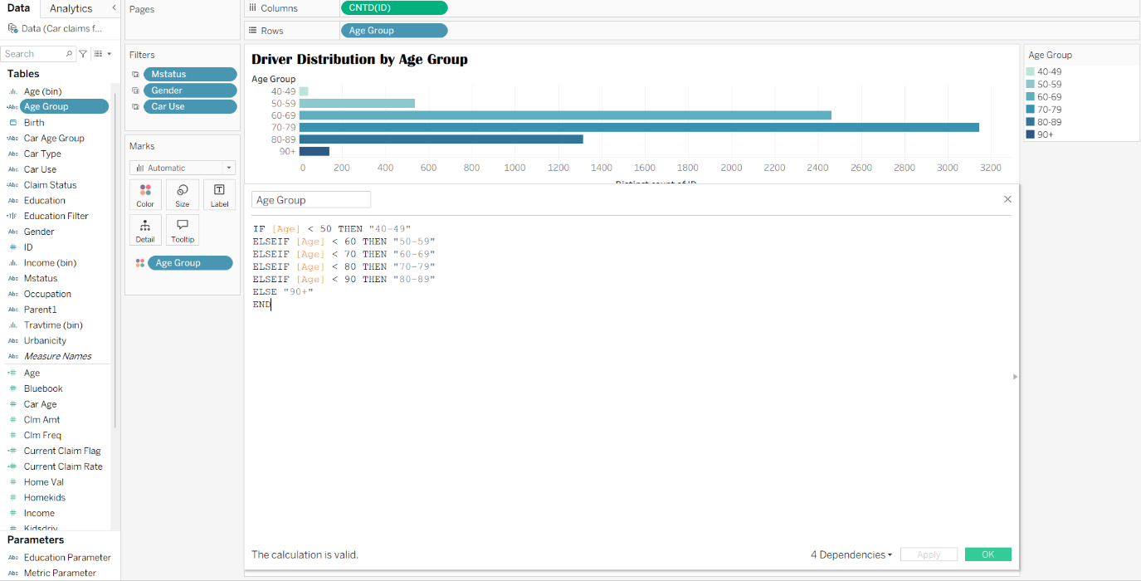

2. Claim Risk Segment
A second calculated field, Claim Risk Segment, was created using CLM_AMT and CLM_FREQ. Customers were categorized into No Claim, Claimed, and High Claim Risk groups based on their claim amount and claim frequency.
This calculation adds business value by helping the insurance company identify customers with higher claim activity and understand potential risk segments. It can support risk assessment, customer segmentation, pricing decisions, and claim management.
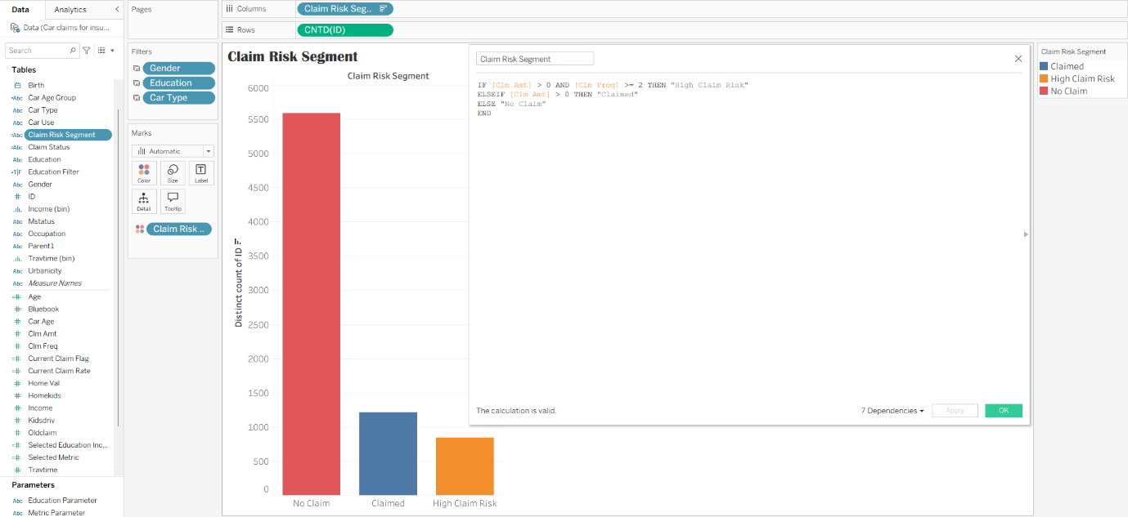

Overall Purpose
These calculated fields transform the raw customer and claims data into meaningful business categories. Age Group supports customer profiling, while Claim Risk Segment supports insurance risk analysis and decision-making.

- Parameter Creation
Two parameters were created in Tableau to improve interactivity and visualization flexibility in the insurance claims analysis.
1. Education Level Parameter
An Education Parameter was created to allow users to interactively filter the analysis based on the driver's EDUCATION level. The parameter includes All, <High School, High School, Bachelors, Masters, and PhD options.
A supporting calculated field was used to apply the selected parameter value as a filter to the visualizations.
This allows users to compare customer profiles, income, claims and other business measures across different education groups without manually changing the worksheet filters.
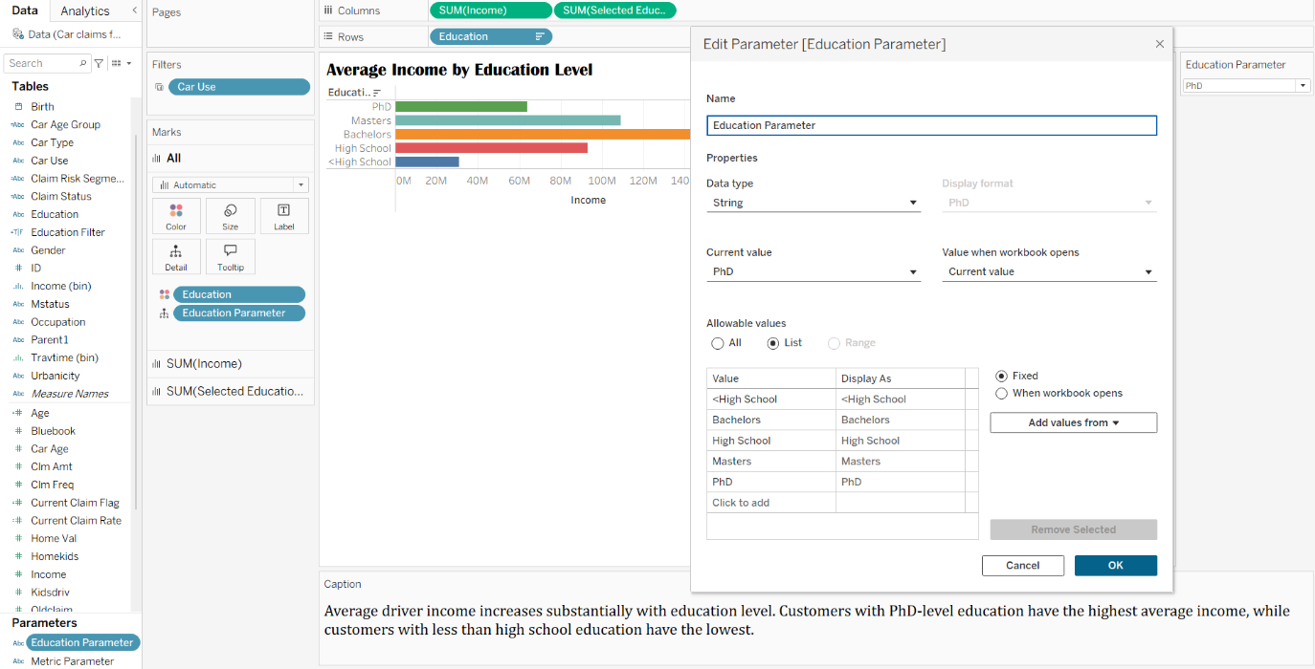
Business value:
The parameter supports interactive customer segmentation and helps analyse how education level influences income, vehicle characteristics and insurance-related behaviour.

2. Metric Parameter
A second parameter, Metric Parameter, was created to improve visualization flexibility by allowing users to switch the business metric displayed in a chart.
The parameter allows users to select between:
- Average Claim Amount
- Average Income
- Average Car Value
- Average Previous Claim
A calculated field dynamically displays the selected metric.
This parameter is used in the Dynamic Metric visualization and allows the same chart to provide different business perspectives without creating multiple separate charts.
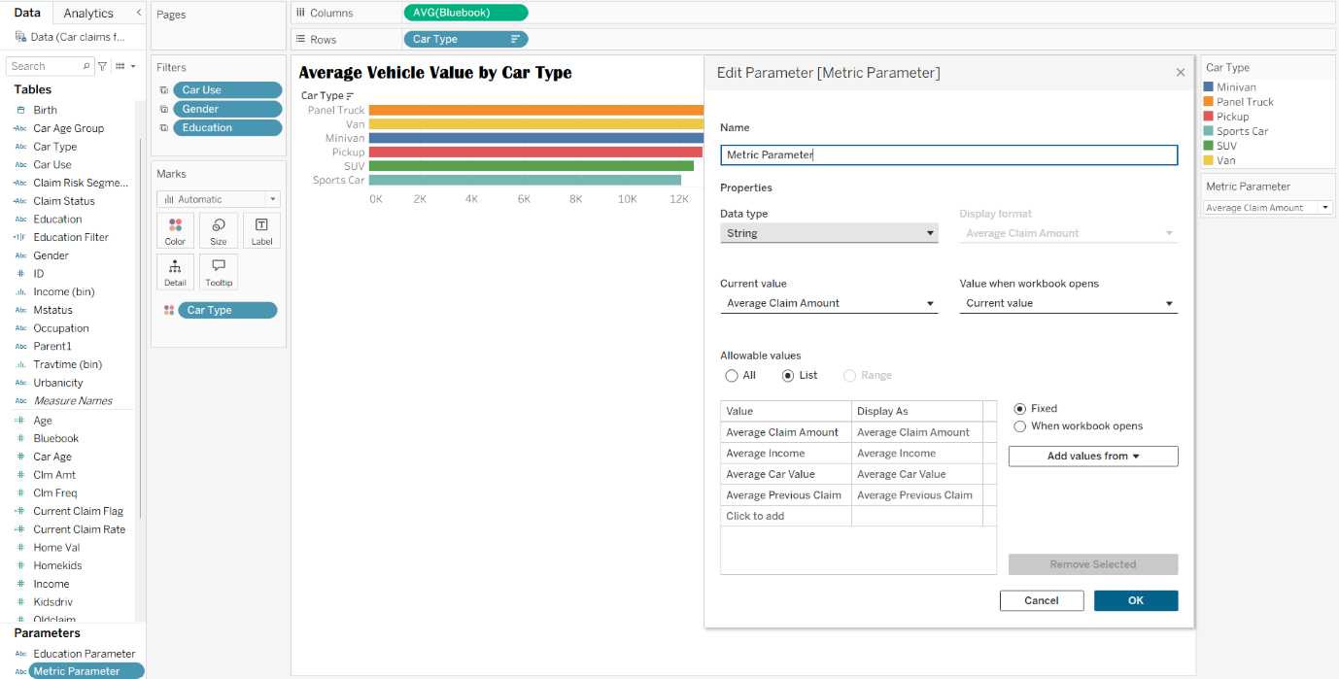
Business value:
The parameter makes the dashboard more interactive and allows management to quickly compare different customer and financial metrics while keeping the dashboard simple and less cluttered.

Overall Purpose
The two parameters improve the interactivity, flexibility and usability of the Tableau dashboards. The Education Parameter enables education-based filtering, while the Metric Parameter allows users to dynamically change the measure being analysed. Together, they support more flexible customer segmentation and business analysis.

- Dashboard Creation
Five business-focused dashboards were created using the visualizations developed during the analysis. Each dashboard combines related charts to present clear and meaningful insights from different aspects of the car insurance claims data.
Dashboards Created
Dashboard 1 – Driver Age & Customer Profile
analysis customer age distribution and age groups to understand the overall customer profile.
Business insight: The customer base is concentrated mainly in the 60–89 age range, with the 70–79 group being the largest.
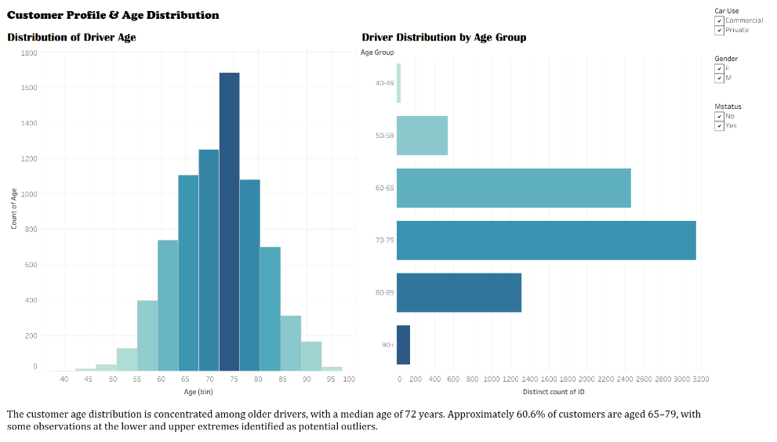

Dashboard 2 – Education & Income Profile
Examines the relationship between education level and customer income.
Business insight: Average income increases substantially with education, with Masters and PhD customers having the highest average income.
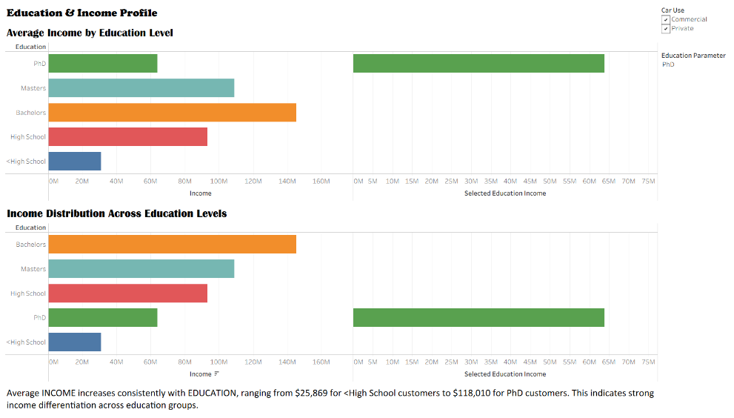
Dashboard 3 – Vehicle Age & Claim Frequency
Studies whether vehicle age has an impact on claim frequency.
Business insight: Vehicle age has only a weak relationship with claim frequency, indicating that vehicle age alone is not a strong predictor of claims.
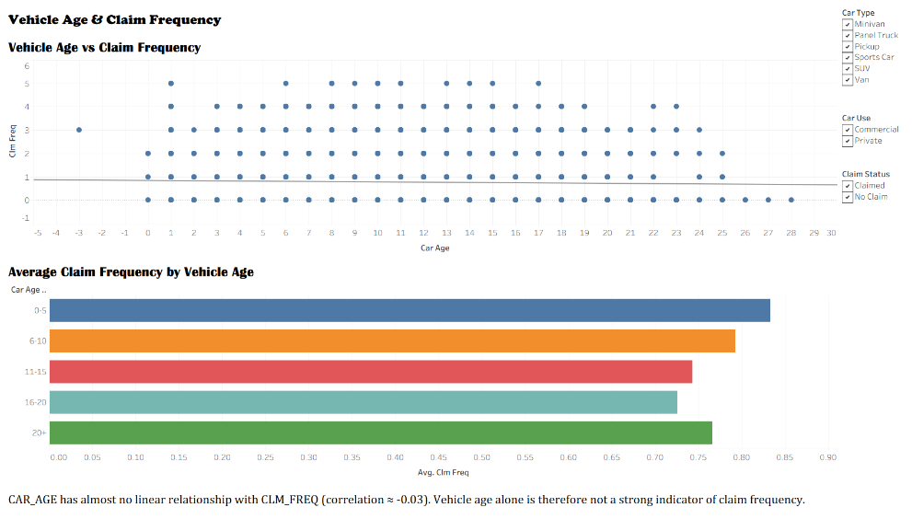

Dashboard 4 – Claim Amount & Risk Profile
Compares claim amounts across vehicle usage, gender and car type.
Business insight: Commercial customers have higher average claim amounts than Private customers, making Commercial usage an important segment for claim-cost management.
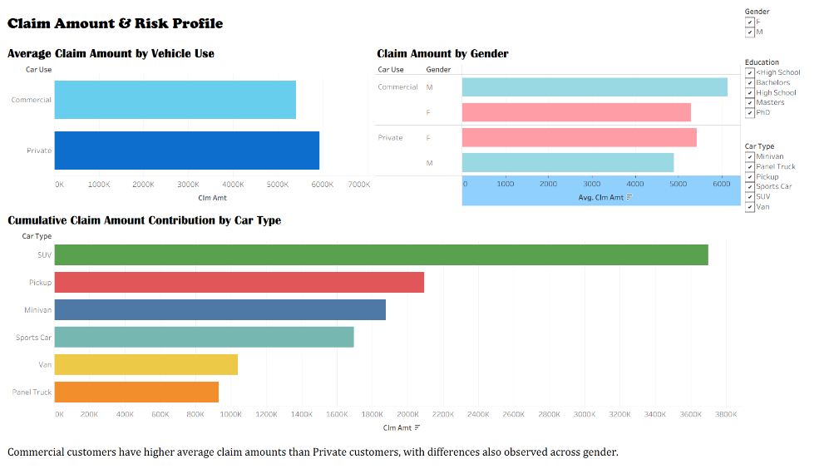

Dashboard 5 – Vehicle Value & Customer Profile
analysis vehicle value across car types and customer marital status.
Business insight: Vehicle value varies considerably by car type, with Panel Trucks having the highest average BLUEBOOK value.
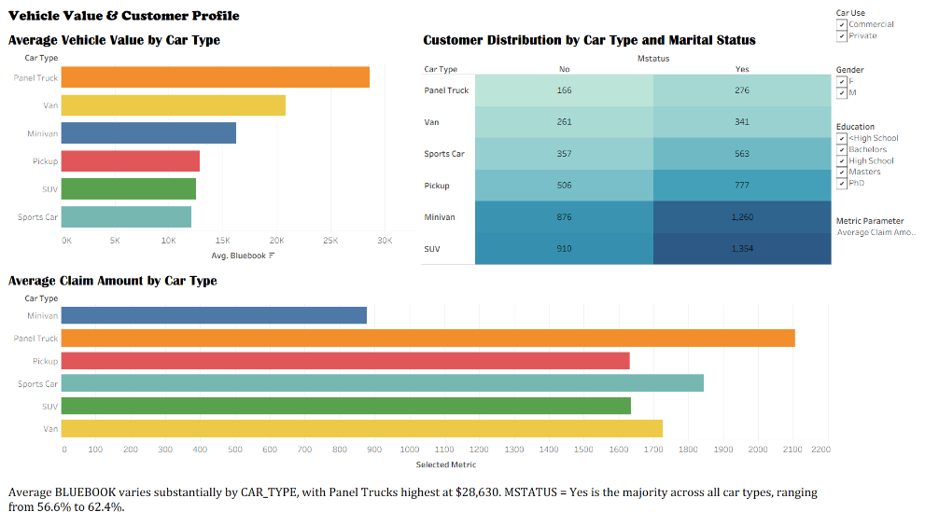

Overall Business Value
The dashboards convert individual visualizations into an interactive business story. They help identify customer segments, income patterns, vehicle characteristics and claim-risk areas, supporting better customer segmentation, pricing decisions, claim management and risk assessment.
Overall, the dashboards provide management with a clear progression from customer profile → financial profile → vehicle behaviour → claim risk → business opportunities.

- Storyboard Creation
A Tableau storyboard was created by arranging the dashboards in a logical sequence so that the visualizations work together to communicate the complete business story.
Storyboard Sequence
EDA – Customer & Vehicle Overview
Provides an overall understanding of customer demographics, vehicle types, vehicle usage, income and occupations.
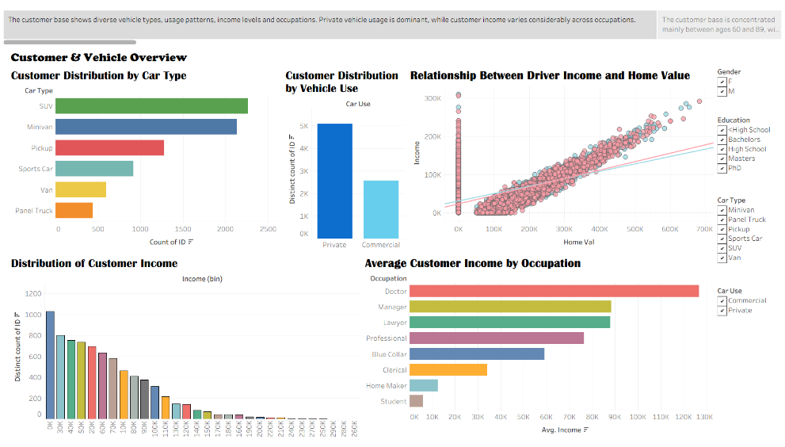
Driver Age & Customer Profile
Examines the age distribution of customers and identifies the major age groups.
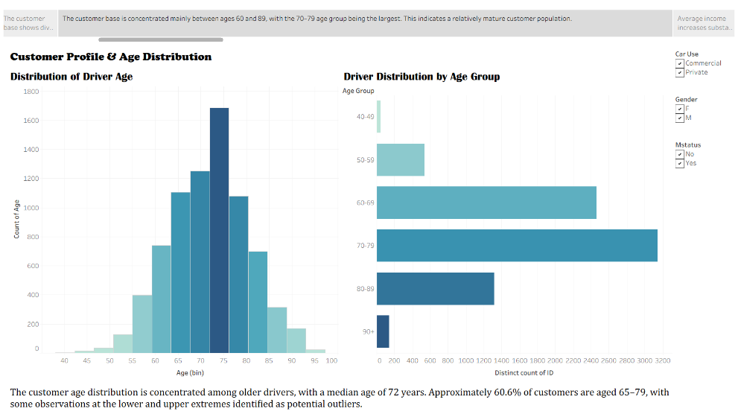
Education & Income Profile
Analyzes how income varies across different education levels and identifies higher-value customer segments.
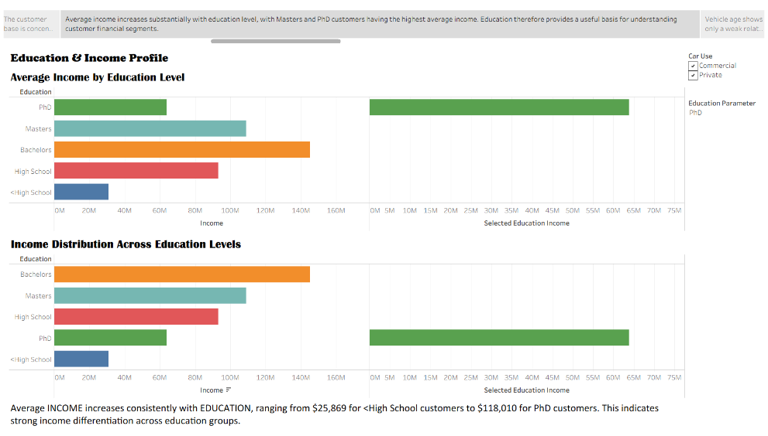
Vehicle Age & Claim Frequency
Examines whether vehicle age is associated with claim frequency and evaluates its usefulness as a risk indicator.
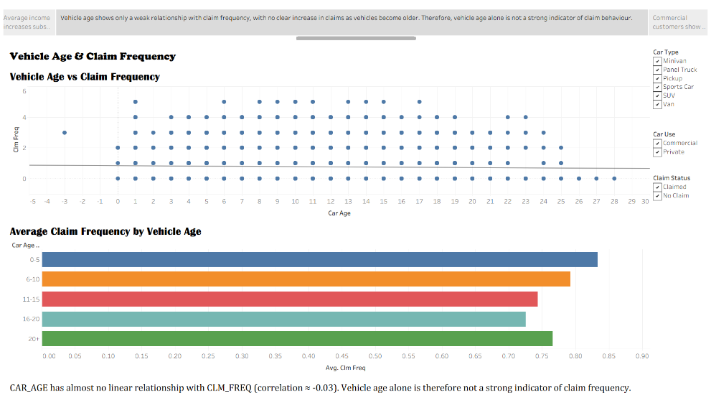
Claim Amount & Risk Profile
Compares claim amounts across vehicle usage, gender and car type to identify higher-cost claim segments.
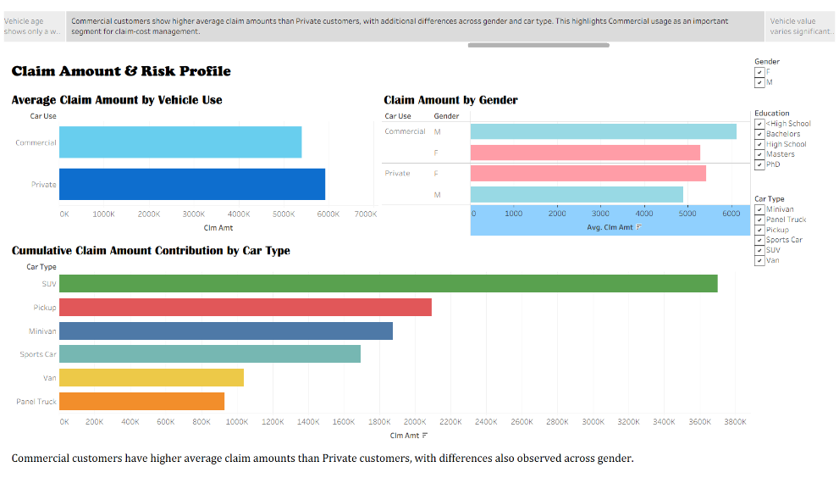
Vehicle Value & Customer Profile
Analyzes vehicle value across car types and customer characteristics to understand potential financial exposure.
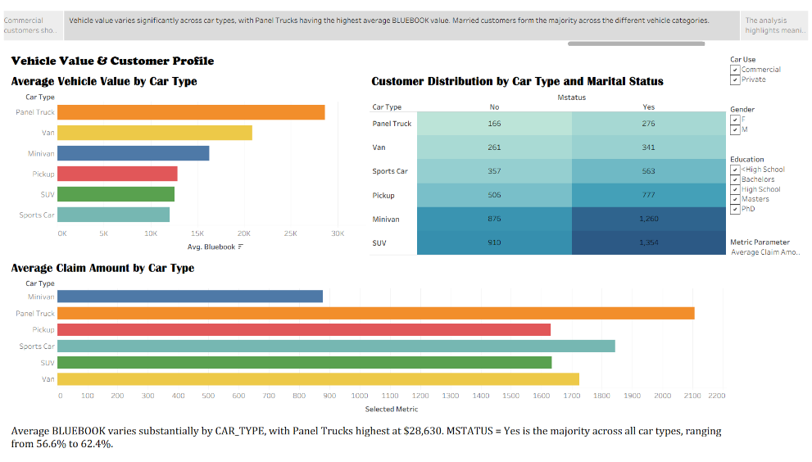
Executive Summary
Brings together the major findings, business insights and recommendations from the complete analysis.
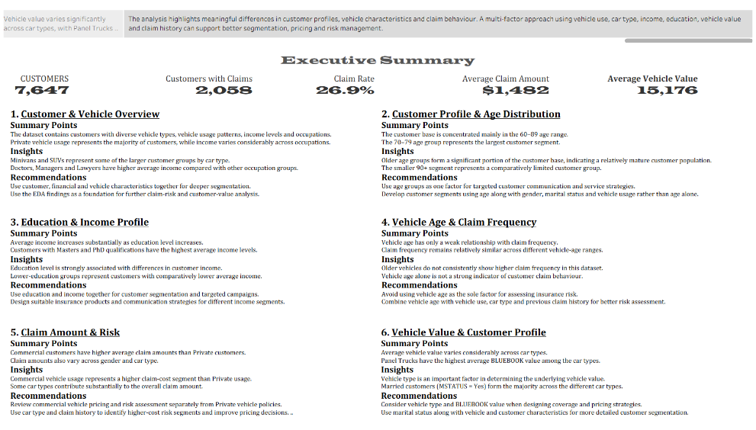
Business Value
The storyboard presents the analysis as a connected business story rather than a collection of individual charts. It starts with understanding the customers, moves into their financial and vehicle characteristics, evaluates claim behaviour and risk, and finally summarizes the key findings and recommendations for management.
This sequence helps insurance management identify important customer segments, claim-cost patterns and risk factors, supporting better segmentation, pricing, claim management and business decision-making.

- Executive Summary
An Executive Summary dashboard was created as the final part of the Tableau storyboard. It brings together the most important findings and recommendations from all five business dashboards in a concise, management-friendly format.
As required, this dashboard contains no charts or visualizations. It uses text, KPI-style summary cards and recommendation sections to communicate the key business outcomes.
Summary & Recommendations by Dashboard
1. Driver Age & Customer Profile
Summary: The customer base is concentrated mainly in the 60–89 age range, with the 70–79 group being the largest.
Recommendation: Use age as one factor in customer segmentation and combine it with vehicle usage and other customer characteristics.

2. Education & Income Profile
Summary: Average income increases substantially with education, with Masters and PhD customers having the highest average income.
Recommendation: Use education and income levels to create meaningful customer segments and targeted insurance offerings.

3. Vehicle Age & Claim Frequency
Summary: Vehicle age has only a weak relationship with claim frequency, so older vehicles do not consistently result in higher claim frequency.
Recommendation: Avoid using vehicle age alone for risk assessment; combine it with claim history, vehicle type and usage.

4. Claim Amount & Risk Profile
Summary: Commercial customers have higher average claim amounts than Private customers, with additional differences across gender and car type.
Recommendation: Review Commercial customers separately for pricing and claim-cost management and use car type and claim history for risk segmentation.

5. Vehicle Value & Customer Profile
Summary: Vehicle value varies considerably across car types, with Panel Trucks having the highest average BLUEBOOK value.
Recommendation: Consider vehicle type and vehicle value when assessing coverage, pricing and financial exposure.

Story Conclusion
Conclusion 1: Customer demographics, education, income, vehicle characteristics and usage patterns together provide valuable information for understanding insurance customer and claim behaviour.
Conclusion 2: A multi-factor risk assessment approach using CAR_USE, CAR_TYPE, EDUCATION, INCOME, BLUEBOOK and claim history can support better customer segmentation, pricing and claim management.

Overall Business Value
The Executive Summary provides senior management with a concise view of the complete analysis. It converts the findings from the storyboard into actionable business recommendations without adding additional visualizations.

- Quality of Submission
The Tableau submission follows the required quality checklist to ensure that the dashboards are clear, interactive, consistent and easy to understand. The visual design and storyboard structure were standardized across the complete analysis.
Quality Checklist Followed
- Filters and Actions: Relevant filters such as GENDER, EDUCATION, CAR_USE and CAR_TYPE were added to allow users to explore the dashboards interactively. Dashboard actions were used where appropriate to connect related visualizations.
- Minimal Clutter: Only relevant charts and information were included on each dashboard. Unnecessary elements were removed to maintain a clean and professional appearance.
- Consistent Colours: A consistent colour scheme was maintained across charts and dashboards so that similar categories are represented consistently throughout the analysis.
- Dashboard Interactivity: Related charts were designed to work together, allowing selections and filters to provide a more interactive analysis experience.
- Logical Story Flow: The storyboard follows a clear sequence from EDA → Customer Profile → Education & Income → Vehicle & Claims → Claim Risk → Vehicle Value → Executive Summary.
- Standard Font Style and Size: Consistent and readable fonts, sizes and formatting were maintained across dashboards, titles, labels and text sections.
- Containers and Alignment: Appropriate horizontal and vertical containers were used to organize charts, filters and text. Elements were properly aligned to create a balanced dashboard layout.
- Legends: Legends were included where required to clearly explain categories, colours and measures. Unnecessary legends were removed to reduce clutter.
- Headers and Titles: Every dashboard and visualization has a clear, meaningful title that explains what is being analysed. Titles and section headers were kept consistent throughout the workbook.
Overall Quality
The final Tableau submission is designed to be clean, consistent, interactive and business-focused. The quality checklist ensures that users can easily navigate the dashboards, understand the visualizations and follow the business story from data exploration to actionable recommendations.

